**Topics: Descriptive Statistics and Probability**

1. Look at the data given below. Plot the data, find the outliers and find out $μ, σ, σ^{2}$

|  |  |
| --- | --- |
| **Name of company** | **Measure X** |
| Allied Signal | 24.23% |
| Bankers Trust | 25.53% |
| General Mills | 25.41% |
| ITT Industries | 24.14% |
| J.P.Morgan & Co. | 29.62% |
| Lehman Brothers | 28.25% |
| Marriott | 25.81% |
| MCI | 24.39% |
| Merrill Lynch | 40.26% |
| Microsoft | 32.95% |
| Morgan Stanley | 91.36% |
| Sun Microsystems | 25.99% |
| Travelers | 39.42% |
| US Airways | 26.71% |
| Warner-Lambert | 35.00% |

Mean= 0.3327133333333333

Variance= 0.028714661238095233

Std= 0.16945400921222029

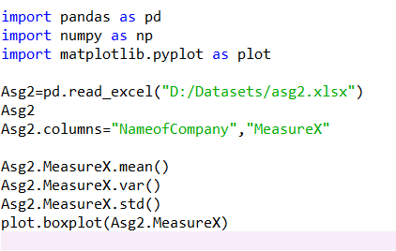

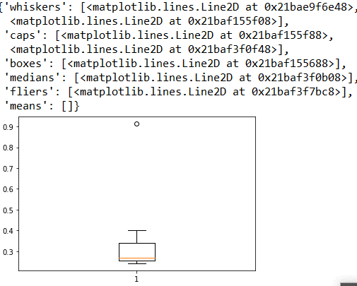

Yes there are outliers present in the dataset. Which can be seen in Upper extreme.



Answer the following three questions based on the box-plot above.

1. What is inter-quartile range of this dataset? (please approximate the numbers) In one line, explain what this value implies.

The IQR =12 – 5= 7 range is 12 to 5 This implies the length of the box from upper quartile to lower quartile.

1. What can we say about the skewness of this dataset?

The Skewness of above boxplot is positive.

1. If it was found that the data point with the value 25 is actually 2.5, how would the new box-plot be affected?

It may act as outlier of new boxplot



Answer the following three questions based on the histogram above.

1. Where would the mode of this dataset lie?

Mode =21,mode lies data point of 4 to 8

1. Comment on the skewness of the dataset.

Positive Skewness of the data.Since the data lies on left hand side and the tail extends towards right hand side.

1. Suppose that the above histogram and the box-plot in question 2 are plotted for the same dataset. Explain how these graphs complement each other in providing information about any dataset.

In the both visualization the skewness of the data is positive .The outlier will be present in both plot . In histogram the mode is 20 and the outlier is 25.While in the box plot the mean is 7 and IQR ranges from 12 to 5.

1. AT&T was running commercials in 1990 aimed at luring back customers who had switched to one of the other long-distance phone service providers. One such commercial shows a businessman trying to reach Phoenix and mistakenly getting Fiji, where a half-naked native on a beach responds incomprehensibly in Polynesian. When asked about this advertisement, AT&T admitted that the portrayed incident did not actually take place but added that this was an enactment of something that “could happen.” Suppose that one in 200 long-distance telephone calls is misdirected. What is the probability that at least one in five attempted telephone calls reaches the wrong number? (Assume independence of attempts.)

One wrong number out of 200 .Therefore the probability of p(wN)=1/200=0.005

Probability of not having a wrong number 1-P(wN)= 1-0.005= 0.995

Probability of 1 out of 5 is wrong number=1-(1-0.005)^5=1-0.975=0.024=2.5%

1. Returns on a certain business venture, to the nearest $1,000, are known to follow the following probability distribution

|  |  |
| --- | --- |
| x | P(x) |
| -2,000 | 0.1 |
| -1,000 | 0.1 |
| 0 | 0.2 |
| 1000 | 0.2 |
| 2000 | 0.3 |
| 3000 | 0.1 |

1. What is the most likely monetary outcome of the business venture?

-2000*0.1+-1000*0.1+0+1000*0.2+2000*0.3+3000*0.1=800

1. Is the venture likely to be successful? Explain

If the venture can maintain long term business then it can be successful

1. What is the long-term average earning of business ventures of this kind? Explain

-2000*0.1+-1000*0.1+0+1000*0.2+2000*0.3+3000*0.1=800

1. What is the good measure of the risk involved in a venture of this kind? Compute this measure

The good measure involved in a venture of this kind is standard deviation